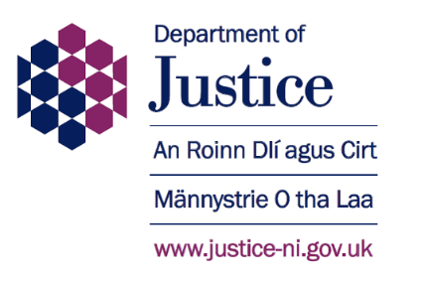
Independent Assessor of PSNI Recruitment Vetting

The Department of Justice (DoJ) is seeking to appoint an Independent Assessor of Police Service of Northern Ireland (PSNI) Recruitment Vetting.

The Independent Assessor is a public appointment made by the Minister of Justice in accordance with legislation [SR 2001 No. 140]. The Regulations which govern this appointment require that the Independent Assessor shall have held judicial office within any part of the United Kingdom. Candidates must also meet the following essential criteria: Making Effective Decisions, Effective Communication, Managing a Quality Service and Contextual Awareness. The appointment will commence on 1 May 2021 and will be for a
4-year term.

The Independent Assessor provides an appeals procedure for candidates disqualified from appointment to the Police Service of Northern Ireland on police vetting grounds, should the candidate so request.

The Independent Assessor will receive annual gross remuneration of £8,250, plus a per diem fee payable in accordance with the fees schedule for judicial office holders in Northern Ireland. Time commitment is led by PSNI recruitment but is anticipated to equate to approximately 10-12 judicial sitting days per year.

The deadline for receipt of applications is 12 Noon on 5 February 2021. Late applications will not be accepted.

A candidate information pack and application form can be obtained as follows:-

Website: Download directly from the Public Appointments page on the DoJ website: https://www.justice-ni.gov.uk/doj-public-appointments

Email to: indassessor@justice-ni.x.gsi.gov.uk

Telephone: 028 90528696

By writing to: Independent Assessor Appointment 2020, Department of Justice, Room A4.16, Castle Buildings, Stormont, Belfast, BT4 3SG

The DoJ is committed to the principles of public appointments based on merit, with independent assessment, openness and transparency of process. The DoJ is committed to providing equality of opportunity and welcomes applications regardless of religious belief, gender, gender identity, disability, race, political opinion, age, marital status, sexual orientation, or whether or not you have dependants. Applications are particularly welcome from women, young people, members of ethnic minority communities and people with disabilities as these groups are currently under-represented in these types of roles. If you require the documents in an alternative format, please contact us at the above address.
